**Enhancing To-Do Lists with Priority Pinned, Categories, and Database Integration**

**Members:**

**Agonoy, Alexis Greko F.**

([alexisagonoy0107@gmail.com](mailto:alexisagonoy0107@gmail.com))

**Bande, Meliza H.**

([melizahonorio0@gmail.com](mailto:melizahonorio0@gmail.com))

**Ragiles, Tristan Bren V.**

([tristan082300@gmail.com](mailto:tristan082300@gmail.com))

**Torralba, Laiza Marie P.**

**(**[**laizatorralba2@gmail.com**](mailto:laizatorralba2@gmail.com)**)**

**Valdez, Kate Ashley R.**

([kateashleyvaldez19@gmail.com](mailto:kateashleyvaldez19@gmail.com))

March 2024

1. **Introduction**

In today's digital landscape, to-do lists have become indispensable tools for managing tasks efficiently and enhancing productivity. However, traditional to-do lists often fall short in meeting the dynamic demands of modern work environments. They lack features such as task prioritization, categorization, and integration with external databases, leading to challenges in organizing, filtering, and collaborating on tasks effectively.

Customer feedback, market trends, and productivity metrics all underscore the importance of enhancing to-do lists with priority pinning, categories, and database integration to address these shortcomings. By incorporating these advanced features, to-do lists can better adapt to the diverse needs of users and organizations, ultimately facilitating streamlined workflows and improved task management practices.

1. **Current Process Analysis**

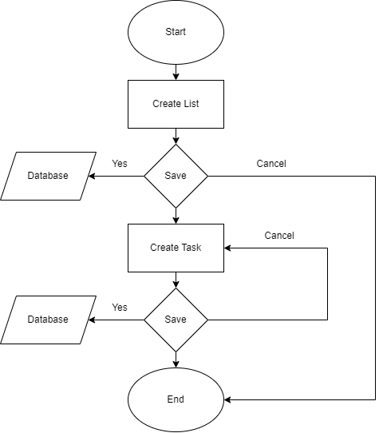

In the diagram after creating a list you have an option to save the list if not the program will immediately end, when you save the list the list will be saved in the database, after creating a list you will create a task and also when saved will be directed to the database if not you will return to create a task

1. **Proposed Improvement**

In this topic, several enhancements are needed, including categorization. Therefore, the researchers aim to improve the To-do List by integrating a database engine. This enhancement will enable users to view completed tasks and save them conveniently. Additionally, the researchers plan to introduce a priority section, allowing users to identify and prioritize tasks effectively.

1. **Benefits & Impact**

Improved task prioritization, organization, productivity, and collaboration are just a few advantages of integrating databases, categories, and priority pinning into to-do lists. With the help of these capabilities, users may more easily and efficiently accomplish their goals, make wise judgments, and better manage their tasks.

* Easier to locate and focus on tasks within specific areas
* Helps focus on what matters most and prevents them from getting overwhelmed by less critical tasks
* Increased productivity of users
* Provides flexibility for a personalized productivity system that aligns with individual goals and workflows
* Provide valuable insights into users' behaviors
* Helps identify areas for improvement in time management and task prioritization
* Helps facilitate collaboration by coordinating tasks within teams or managing shared responsibilities
* Streamlines workflows and eliminates the need for manual data entry across multiple tools

1. **Project Plan & Timeline**

**Phase 1: Planning and Requirements Gathering**

Duration: 2 days

**Milestones:**

1. Define project scope, objectives, and requirements.
2. Conduct market research to identify existing to-do list applications and features.

**Resources Needed:**

1. Project manager
2. Programming Languages: HTML, CSS, Javascript.
3. Integrated Development Environments (IDEs): Visual Studio.
4. Version Control: Git

**Phase 2: Design and Prototyping**

Duration: 1 weeks

**Milestones:**

1. Design the user interface (UI) for the to-do list application, incorporating priority pinning and categorization features.
2. Create wireframes or mockups to visualize the interface and functionality.
3. Design the database schema for storing tasks, priorities, and categories.

**Resources Needed:**

1. UI/UX designer (HTML & CSS)
2. Prototyping tools (Figma)
3. Database engineer

**Phase 3: Development**

Duration: 2 weeks

**Milestones:**

1. Develop the front-end of the to-do list application using HTML, CSS, and JavaScript.
2. Implement priority pinning and categorization features.
3. Integrate database functionality for storing and retrieving tasks, priorities, and categories.
4. Perform thorough testing and debugging to ensure functionality and usability.

**Resources Needed:**

1. Software developers (front-end and back-end)
2. Database engineer
3. Testing team

**Phase 4: Testing and Quality Assurance**

Duration: 1-2 weeks

**Milestones:**

1. Conduct functional testing of all to-do list features, including priority pinning and categorization.
2. Perform compatibility testing on different browsers and devices.
3. Address any bugs or issues identified during testing.
4. Conduct user acceptance testing to gather feedback and make improvements.

**Resources Needed:**

1. Testing tools
2. Devices for compatibility testing

**Phase 5: Deployment and Launch**

Duration: 1 week

**Milestones:**

1. Prepare the to-do list application for deployment to production servers.
2. Perform final checks and validations before launch.
3. Deploy the application to the targeted platforms (e.g., web, mobile).

**Resources Needed:**

1. Deployment tools
2. **Evaluation & Risk Assessment**

**Measuring Success:**

* User Satisfaction: Feedback on ease of use and effectiveness.
* Task Completion Rate: Percentage of tasks completed.
* Retention: Rate of continued use over time.

**Metrics and Methods:**

* Feedback Surveys: Gather user opinions on usability.
* Task Completion Tracking: Monitor completion rates.
* User Engagement Analytics: Track usage patterns and retention.

**Potential Risks and Mitigation:**

* Technical Issues: Thorough testing and continuous updates.
* User Adoption: Clear instructions and user training.
* Data Security: Implement robust encryption and access controls.

1. **Conclusion**

Our proposal seeks to revolutionize traditional to-do lists by integrating advanced features such as priority pinning, categorization, and database integration. By addressing the limitations of conventional task management tools, our enhanced solution provides users with superior organization, prioritization, and collaboration capabilities. Through features like priority pinning and categorization, users can efficiently organize and prioritize tasks, ensuring they focus on what matters most.

This leads to increased productivity as streamlined workflows and advanced task management enable users to better manage their time and workload. Moreover, the flexibility of our system allows for personalized productivity systems tailored to individual goals and workflows, empowering users to achieve their objectives effectively. Integration with a database engine further enhances the tool by providing valuable insights into user behaviors and facilitating collaboration among teams. Overall, our proposed enhancements promise to streamline workflows, improve productivity, and empower users to manage tasks more effectively.